Early Years Curriculum
Mathematics
At Victoria Road the Early Years Curriculum is research based, understanding that Birth to 5 is a unique neurological and developmental phase. The curriculum plans for concrete learning experiences, the opportunity to revisit ideas in a variety of contexts and the embedding of learning behaviours which underpin the Characteristics of Effective Learning. In the Early Years learning is not compartmentalised and everything links.
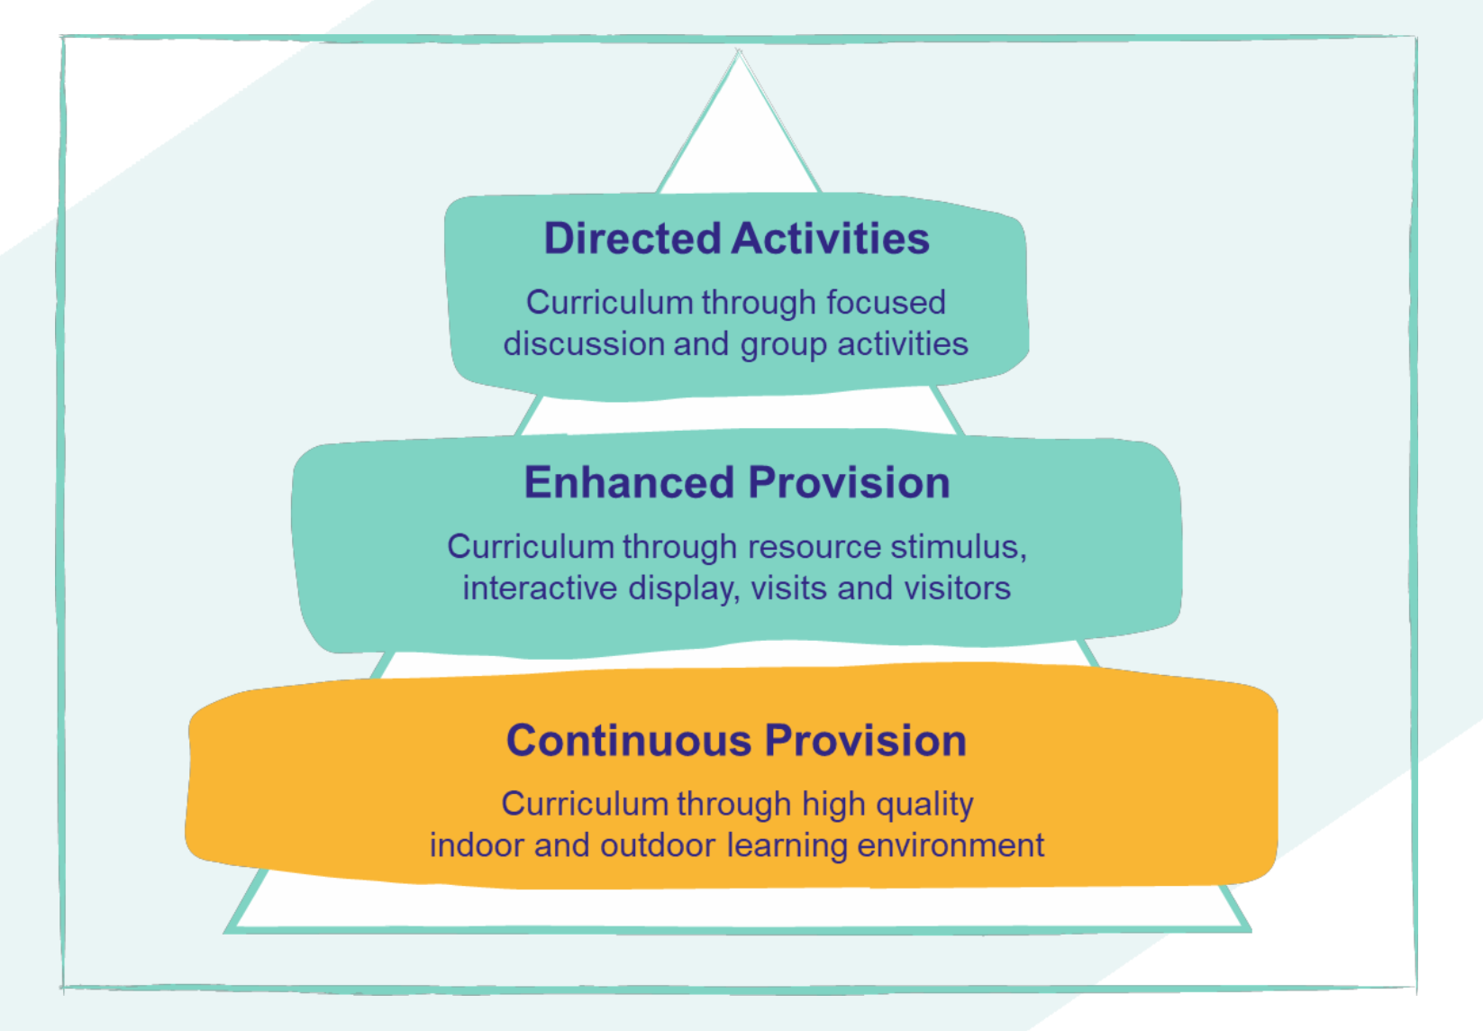
Our Early Years Curriculum is based around the Early Excellence Triangle Model which divides learning into three strands, Continuous Provision, Enhanced Provision and Directed Activities.

In the Early Years children’s Mathematical knowledge is developed through All Strands of the Curriculum Triangle with whole class Directed Activities following the Mastering Number Approach and through child initiated in both the Continuous Provision and Enhanced Provision. Through enhancements, opportunities are made available for children to revisit key concepts that have been taught during whole class directed activities, this may include enhancements that have been used as part of the input for example a set of five frogs and a pond when exploring how to partition the number 5. We understand that numbers can be accessed throughout the provision, however a carefully resourced Number Area is continuously available for children to explore, represent and make sense of concepts including how numbers are composed through self initiated play. In addition, we want to broaden our Early Years Mathematical curriculum to ensure that children are exposed to experiences, concepts and language related to Shape, Space and Measure. Through our Continuous Provision children have the opportunity to explore the properties of 2D and 3D shapes and are exposed to language to support and scaffold their thinking. For example, “the cuboid would be a good choice to build because it has a flat face so will not roll.” In addition through self exploration children can experience comparison and measurement with increasing accuracy.

Links | ELG Maths | Key Stage 1 National Curriculum
DA  Overview  CP  Maths Area  Block Area  Dough Area  Sand Area  Water Area  Small Construction | Mathematics  Number  - Have a deep understanding of number to 10, including the composition of each number;  - Subitise (recognise quantities without counting) up to 5;  - Automatically recall (without reference to rhymes, counting or other aids) number bonds up to 5 (including subtraction facts) and some number bonds to 10, including double facts.  Numerical Pattern  - Verbally count beyond 20, recognising the pattern of the counting system; Compare quantities up to 10 in different contexts, recognising when one quantity is greater than, less than or the same as the other quantity;  - Explore and represent patterns within numbers up to 10, including evens and odds, double facts and  - how quantities can be distributed equally | National Curriculum

